Name __________________________________ AP Calculus
Sections 4.1 and 4.2: Extreme values & Mean Value Theorem

No calculator allowed. Show all your work!
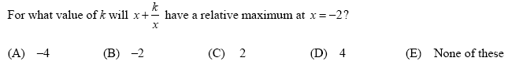
1.

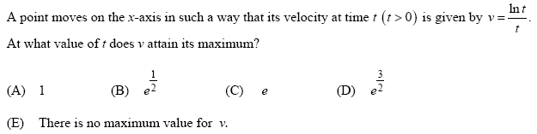
2.

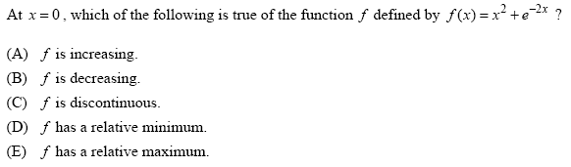
3.

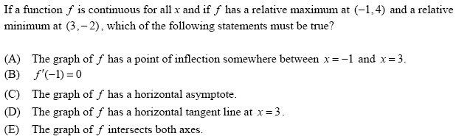
4.

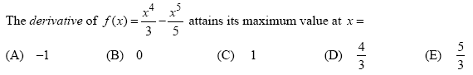
5.

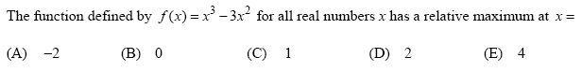
6.

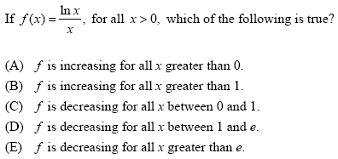
7.

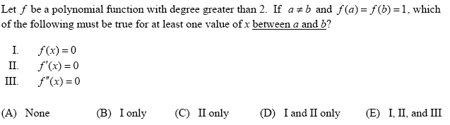
8.

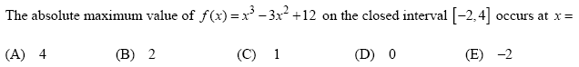
9.

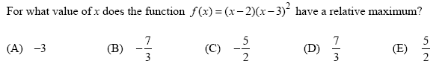
10.

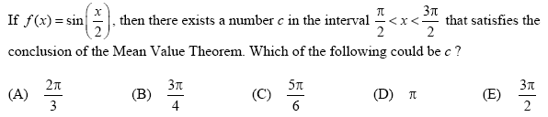
11.

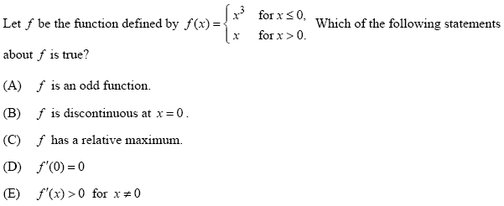
12.

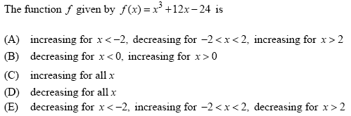
13.

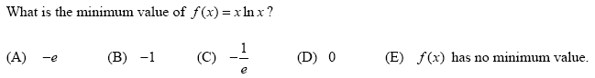
14.

